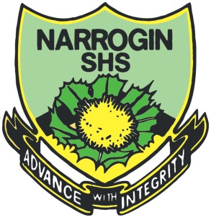

Year 7 Science 2022

**Classification Test**

**SECTION 1: MULTIPLE CHOICE** (1 mark each)

Circle your answer on the multiple choice answer sheet.

1. Which of these features is **least useful** for classifying animals?
   1. Cell and body structure
   2. Body covering
   3. Size
   4. Reproduction method
2. Which class do **humans** belong to?
   1. Animals
   2. Mammals
   3. Reptiles
   4. Amphibians
3. Insects, spiders and crabs are all **classified** as
   1. Vertebrates
   2. Molluscs
   3. Arthropods
   4. Mammals
4. Which of these pairs are most **closely related**?
   1. humans and snails
   2. butterflies and worms
   3. sharks and stingrays
   4. coral and starfish
5. The scientific name of **humans** is
   1. Felis catus
   2. Homo sapiens
   3. Canis vulpes
   4. Eucalyptus marginate
6. Which of these shows **correct sequence** for classification?
   1. Kingdom, Phylum, Class, Order, Family, Genus, Species
   2. Kingdom, Class, Phylum, Order, Family, Genus, Species
   3. Kingdom, Order, Family, Phylum, Class, Genus, Species
   4. Kingdom, Genus, Family, Phylum, Order, Class, Species
7. Which of these is **not** an insect?
   1. Butterfly
   2. Ant
   3. Cockroach
   4. Scorpion
8. Animals with **backbones** are called
   1. invertebrates.
   2. vertebrates.
   3. arthropods.
   4. mammals.
9. Animals that **breathe air** and have **dry scales** are called
   1. reptiles
   2. amphibians
   3. fish
   4. birds
10. **Monotremes, marsupials and placentals** are types of
    1. mammals
    2. birds
    3. amphibians
    4. reptiles



**Classification Test**

**NAME:**

**FORM:** **DATE:**

Multiple Choice Short Answer Total

**/18**

**/10**

**/28**

**SECTION ONE:** Multiple choice answers

Cross (X) through the correct answer.

|  |  |  |  |  |
| --- | --- | --- | --- | --- |
| **1** | a | b | c | d |
| **2** | a | b | c | d |
| **3** | a | b | c | d |
| **4** | a | b | c | d |
| **5** | a | b | c | d |
| **6** | a | b | c | d |
| **7** | a | b | c | d |
| **8** | a | b | c | d |
| **9** | a | b | c | d |
| **10** | a | b | c | d |

**SECTION 2: WRITTEN ANSWER**

Write your answers in the spaces provided.

1. List the **7 life processes** that all living things undergo

1. ___________________
2. ___________________
3. ___________________
4. ___________________
5. ___________________
6. ___________________
7. ___________________ (1 mark each: ____ / 7 marks)

2) The dichotomous key below shows one way of presenting information on the plant

kingdom. Use the key to answer the questions that follow. (2 marks)

Plant Kingdom

No stem, Simple roots

Stem present

No seeds

Has seeds

Flowers

No flowers

Mosses and liverworts

Ferns

Flowering plants

Conifers

List one similarity and one difference between flowering plants and conifers

Similarity

______________________________________________________________________________

Difference

______________________________________________________________________________

3) Use the key below to classify the animals pictured here. (4 marks)

**KEY ANIMAL**

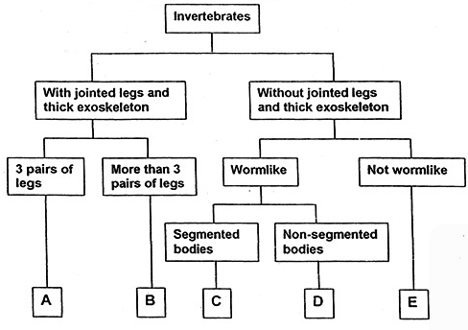

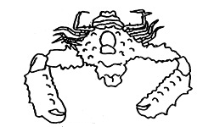

**I**

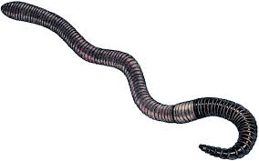

**II**

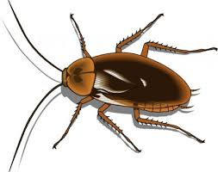

**III**

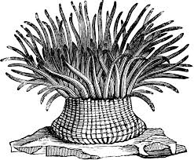

**IV**

|  |  |
| --- | --- |
| **ANIMAL** | **GROUP (A,B,C,D or E)** |
| **I** |  |
| **II** |  |
| **III** |  |
| **IV** |  |

4) Use the key to identify the species name of each of the smileys below then write their name under the correct picture. (5 marks)

|  |  |
| --- | --- |
| 1. | a. Teeth Visible..........................................................go to 2 |
|  | b. Teeth not visible....................................................go to 4 |
| 2. | a. Has a wide, toothy smile ......................................*Smilus toothyus* |
|  | b. Is not smiling ........................................................go to 3 |
| 3. | a. Visibly crying.........................................................*Smilus dramaticus* |
|  | b. Frowning……........................................................*Smilus upsettus* |
| 4. | a. Eyes are symmetrical ...........................................go to 5 |
|  | b. Eyes not symmetrical…........................................go to 8 |
| 5. | a. Eyes shaped like hearts ………………………….*Smilus valentinus* |
|  | b. Eyes shaped as ovals …………………………….go to 6 |
| 6. | a. Smiling, happy face….........................................*Smilus traditionalis* |
|  | b. Not happy, frowning or other……………………..go to 7 |
| 7. | a. Mouth curved down, frowning ............................*Smilus saddus* |
|  | b. Mouth is a small circle.........................................*Smilus suprisus* |
| 8. | a. Has a pirate eye patch........................................*Smilus piratus* |
|  | b. Does not have eye patch ...................................go to 9 |
| 9. | a. One eye is much larger than the other eye........*Smilus muttus* |
|  | b. One eye is winking ............................................*Smilus winkus* |

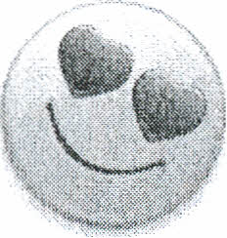

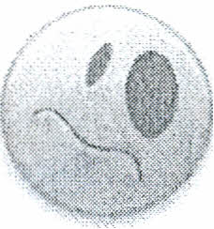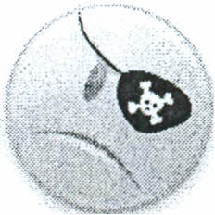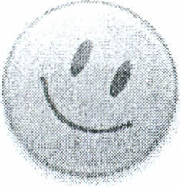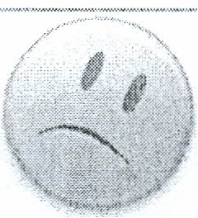

---------------- ----------------- -------------- ---------------- ---------------

---------------- ---------------- -------------- ---------------- ---------------

**END OF TEST**